Typography Tutorial for Beginners: Everything You Need to Learn Typography Basics
Written by Brittany Leaning

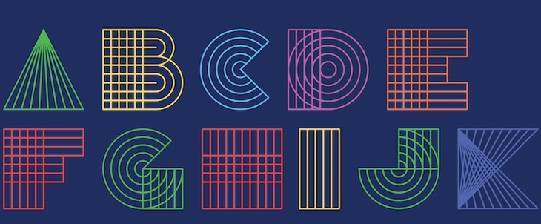
Typography turns out that while the importance of typography is often overlooked, it plays a critical role in strengthening your brand, creating interest in your product, and highlighting your central message.
. What Is Typography?
- Why Is Typography Important?
- Typography Definitions & Terms
- Type Classifications
- Type Families
- Typography Fonts: Resources & Examples

What Is Typography?
It is the art and technique of arranging type, type meaning letters and characters.
It's about more than just the design of letters and characters; the arrangement of those letters and characters is just as big a part of it all. That refers to the selection of point size, line length, and spacing, both on a single line and throughout an entire page or piece of work.
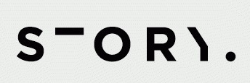
To understand where the importance of arrangement comes in, I like to think back to Johannes Gutenberg's printing press. At one point in time, people practiced typography using printed materials -- meaning they were literally taking letters and characters and arranging them in physical space.
Today, thanks to computers, open source fonts, and scalable computer typography, it's a lot easier to arrange letters and characters. But that physical piece remains important, even in the digital sphere.

Why Is Typography Important?
Because it is everywhere. Just look at your phone, a billboard, your coffee cup, or even the different styles used in this blog post. Every font, letter, and character arrangement plays a part in determining how a message is conveyed.
Even the smallest of type adjustments can impact the look and feel of your work. For example, back in June, Facebook tested a new font on its users called Geneva. While the new font was only slightly thinner and lighter than the original, Helvetica, it made a noticeable difference to some.
"The overall effect is a lighter, more modern looking block of text," explained Chris Mills for BGR.
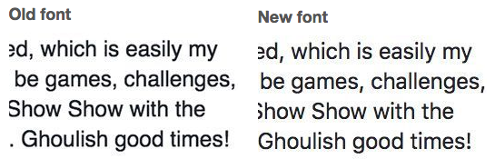
Same goes for when Apple changed its default font from the dramatically thin Helvetica Neue to one they developed in-house called San Francisco.
"The differences between Helvetica and San Francisco are subtle, even to the trained eye, but they’re there," wrote Liz Stinson for WIRED. "While still an austere sans serif, San Francisco is bolder and friendlier than Helvetica Neue. Based on the German typeface DIN, San Francisco gives characters more breathing room, which will make it easier to read on relatively tiny mobile screens. Tall and skinny, San Francisco is space-efficient, like Google’s custom typeface Roboto, which you could consider a close cousin to Apple’s font."
The little details do matter.
Steve Jobs believed that calliigraphy and typography played a critical role in the success of Apple. As he once said in a Stanford University commencement speech, "If I had never dropped in on that single course in college, the Mac would have never had multiple typefaces or proportionally spaced fonts."
Once you realize how much thought goes into carefully selecting a typeface, it becomes much easier to recognize the differences between typefaces and understand why they might’ve been chosen in the first place.
Some examples show what I mean ...
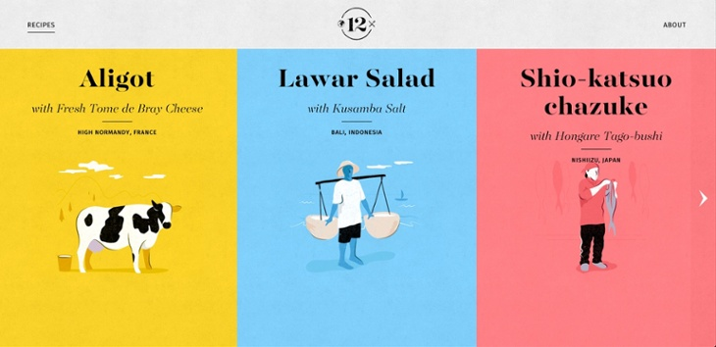
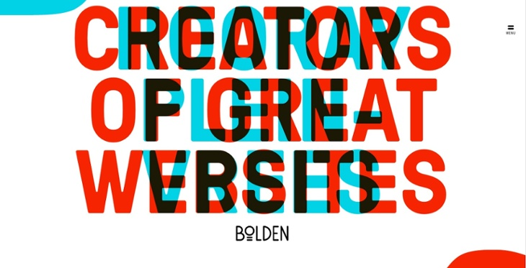
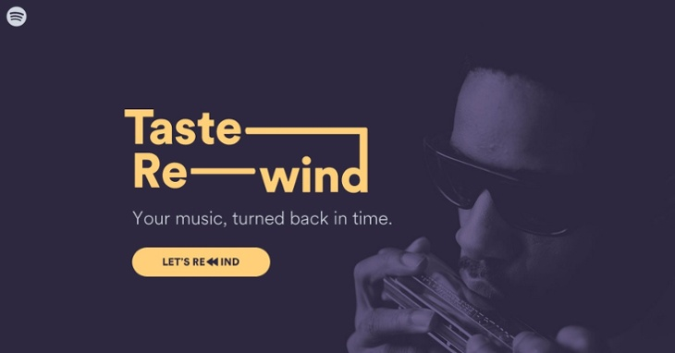
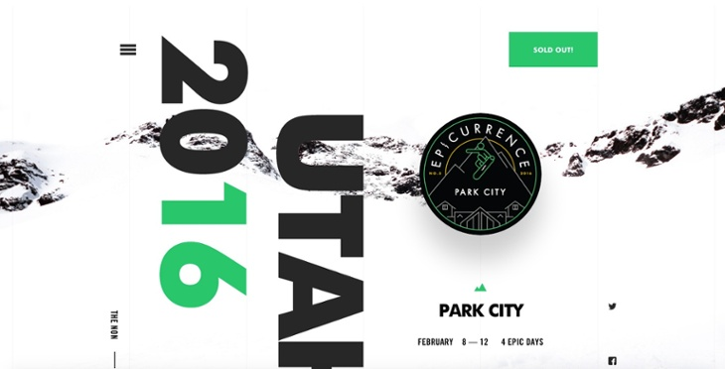

Typography Definitions & Terms

Typefaces vs. Fonts
Typographer, Nick Sherman, once used a great analogy to explain the differences between the terms “typeface” and “font.” He suggested comparing these typography terms to the musical terms “song” and “mp3.” When you’re explaining how much you enjoy a particular tune, you say, “I love this song!” You wouldn’t say, “I love this mp3!” The song is the work of art, whereas an mp3 file is just the delivery mechanism.
The same rules apply in typography. You should use the word “typeface” when describing the creative work (i.e., what you see). This is a more abstract design term used when referring to the way a specific collection looks or feels. For example, Helvetica is a typeface.
If you’re describing the physical embodiment of the collection of letters and characters, you should use the term “font." It refers to what you use -- whether that’s a file on your computer or a case full of metal letters. This is the tangible representation of that collection of letters and characters. For example, Helvetica Bold and Helvetica Light Oblique are fonts.
Here's how you could use these two terms in a sentence:
- “Wow. The typeface you chose really pulls this design together.”
- “I’ll change the font size to 12pt so it fits in the box.”

The Anatomy of a Typeface
Each part of a letter has its own special term, similar to bones in a human body. Below, you’ll see three diagrams that explain the makeup of individual letters, how these elements interact with each other, and how they sit on a line.
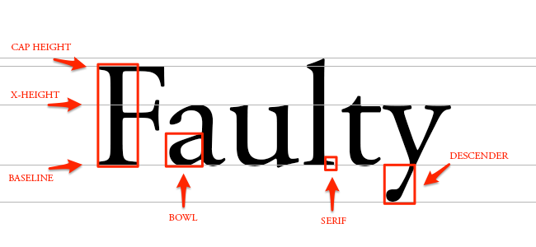DEFINITIONS :
- Baseline: The line where the letters sit.
- Cap height: The distance from the baseline to the top of the capital letter.
- X-height: Located in between the baseline and the cap height, it's the height of the body of the lowercase letter. (In this case, it's the letters ‘a,' ‘u,' and ‘y.')
- Bowl: The curved part of the character that encloses the circular or curved parts of some letters, like 'd,' 'b,' 'o,' 'D,' and 'B.' (In this case, it's that round shape sticking off the letter ‘a.')
- Serif: The slight projection finishing off a stroke of a letter in certain typefaces. (In this case, it's that little foot sticking off the letter ‘l.')
- Descender: The longest point on a letter that falls beyond the baseline.
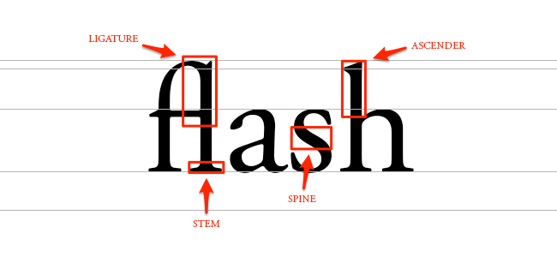
DEFINITIONS:
- Ligature: The stroke that joins adjacent letters. (In this case, you'll notice the 'f' and the 'l' smush together to form one character.)
- Stem: The base of a letter, similar to the stem of a flower.
- Spine: The curvy body of the letter 's' -- and only the letter 's.' It gets its own term because the spine can be almost vertical or mostly horizontal, depending on the typeface.
- Ascender: The portion of a letter that extends above the mean line of a font -- i.e., is taller than the font's x-height. (In this case, you’ll also notice the letter ‘h’ is actually taller than the x-height.)
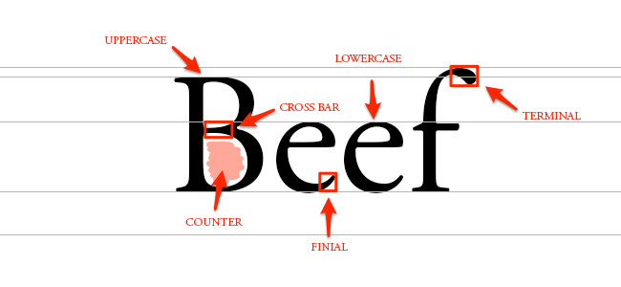

DEFINITIONS :
- Cross bar: The bar that goes across the inside of the letter and connects one side to another. (In this case, it's the bar inside the capital letter 'B.')
- Counter: The empty space in the middle of letters such as ‘B’, ‘O’, or ‘A.'
- Finial: The tapered end of letters such as ‘e’ or ‘c.'
- Terminal: A type of curve that you see at the top of the letter ‘f’ or the end of the letter ‘j.'
SPACING

Kerning: Kerning is the modification of the space between two letters. For example, check out the image below:
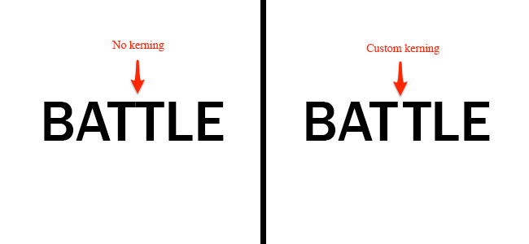
Here, I used Franklin Gothic Medium to showcase the natural space you see between two letter T’s. By customizing the spacing between just these two letters, you'll be able to increase readability.

Tracking: Similar to kerning, tracking deals with a modification to letter spacing. However, instead of adjusting the spacing between just two letters, tracking is an adjustment to the spacing between all letters an entire word. See the difference below:
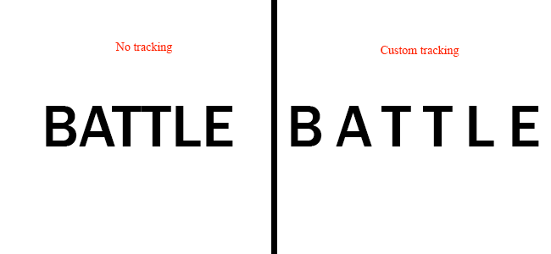
For this example, I chose to make an extreme adjustment to the tracking. Typically, you’d want to apply tracking in small increments to avoid causing readability issues.

Leading: The terms “single-space” and “double-space” can also be called “leading,” which is the distance between the baselines. See leading in action:
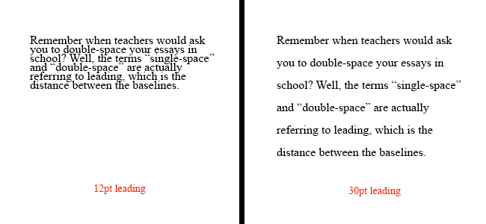
You can choose to increase your leading, creating more space between the baselines, or decrease your leading, which pushes your lines of text closer together. The reason high school teachers asked for essays to be double-spaced was because it’s much easier to read, and they could make corrections to the text more easily.

Hierarchy: In this document, certain words stand out more than others. That's what designers would call creating a hierarchy. You can use different weights (bold, regular, light), styles (italic), and sizes to create a sense of order within your text. Not only does this help create a legible flow, but it helps the reader see what the most important points are.
Here's an example of what hierarchy looks like: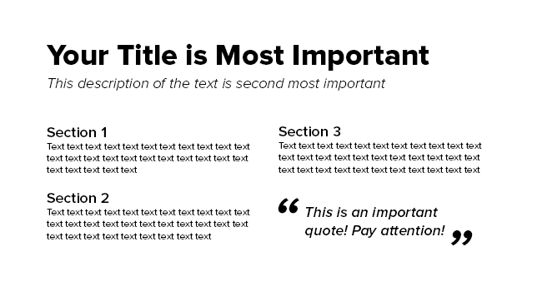
In most cases, you want people to read the title first. That's why you'll see most titles are much bigger and bolder than the body text. Call-out quotes and descriptive sentences can also stand out above the rest of the text using techniques such as bolding and italicizing.
With effective hierarchy, the reader should be able to jump from one section to the next to identify the most important points.

Type Classifications: The two main type classifications you see are called serif and sans serif. Other classifications include slab serif, black letter, script, modern, and decorative.

Serif: Typefaces with feet like in the example about the word “faulty” are called serif. You can see where I highlighted these little feet below: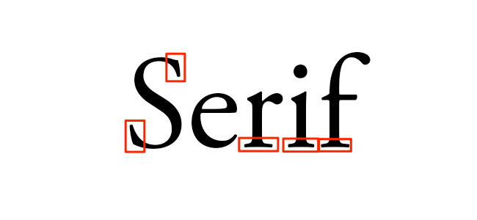
Common serif typefaces include Times New Roman, Georgia, and Garamond. If you’re reading a novel, you might notice the body text is a serif. That’s because a serif is much easier to read in long, printed works due to the distinctiveness between letters.

Sans Serif
In French, the word “sans” means “without.” So the term “sans serif” literally means “without serif.” In the image below, you’ll notice the words lack serifs, as I pointed out with the red arrows.
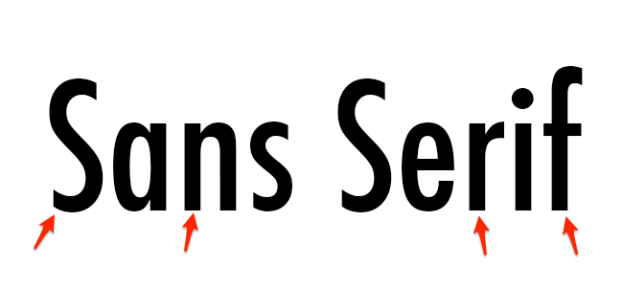
Common sans serif typefaces include Arial, Verdana, and Futura. You’ll see a lot of sans serifs being used in blog posts and documents on the web because it feels more modern and looks great even at lower screen resolutions.

Black letter
Black letter typefaces, also referred to as Gothic, Fraktur or Old English, are known for its dramatic thick and thin strokes and its elaborate swirls on the serifs. These typefaces are based on early manuscript writing -- in fact, black letters were used in Gutenberg's Bible, one of the first books ever printed in Europe. They were much more popular before 1500 than they are today.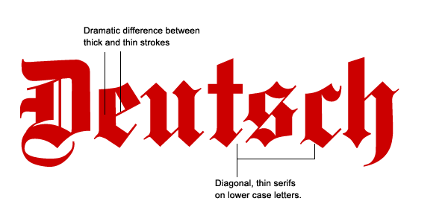
Black letters are pretty hard to read, which is why they're not typically used for body type. They can be seen n headers, logos, posters, and signs -- like on newspaper nameplates (New York Times' logo) or on the headers of certificates, diplomas, or degrees. Common black letter fonts include Cloister Black, Deutsche Zierschrift, and Germanica.
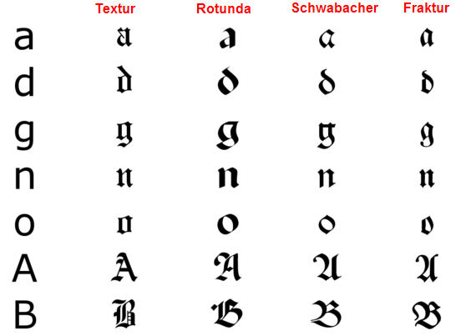

Script: Script typefaces are based upon the varied and often fluid strokes created by handwriting. As scalable computer typefaces, characters in these scripts can now string together with one another automatically so they convincingly mimic handwriting, rather than users having to manually pick and choose which letters go after which -- which you can imagine was a painstaking process.
Under the umbrella of a script typeface, there are two basic classifications: formal and casual. Formal scripts are often reminiscent of the handwritten letterforms common in the seventeenth and eighteenth centuries, and they’re used for elegant designs like invitations and diplomas, not for body copy.
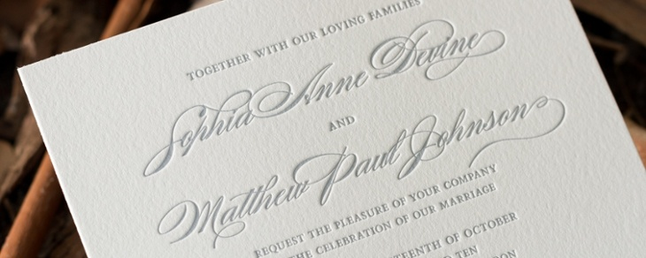
Casual scripts, or informal scripts, are just that: less formal script typefaces that look more like everyday handwriting
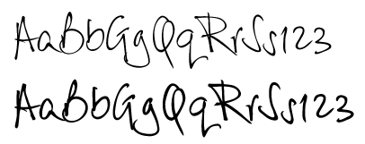
Those are just a few examples of type classifications to give you an idea of how they work.

Type Families: The term “type family” or “typeface family” is used to describe a range of designs that are all variations of one basic typeface.
For example, you’ll see that Proxima Nova has variations such as bold, extra bold, black, regular, light, light italic, and regular italic:
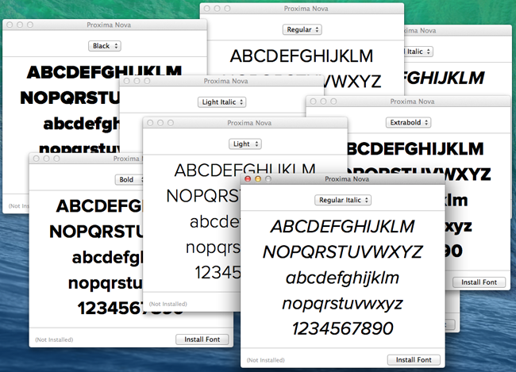
Sticking to a single type family will help add variation to your designs, while keeping it consistent and uniform.
Designers might use various fonts within one family to create a sense of hierarchy -- designing so that the most important elements, such as headlines and quotes, stand out above the rest of the text.

Typography Fonts

Great Resources for Free Fonts
- "35 of the Best Free Fonts You Should Download": A HubSpot blog post curating 35 of the best free fonts on the internet.
- Google Fonts: Hundreds of free, open-source fonts from Google that are already optimized for the web.
- Behance: A great resource for finding beautiful design work, including unique fonts that are free to download.
- HypeForType: Over 25,000 typography designs from top designers, many of which are available to download for free.

8 Cool Fonts That Are Free to Download

1) Crimson Text
Here's one that's great for body copy. It was meant for book production, according to Google Fonts, so it's easy to read. But at the same time, there's a lot to it that makes it special: old-style figures, small caps, fleurons, and math characters and the like. It comes in three styles -- Regular, Light, and Bold -- along with the italic styles of those weights.
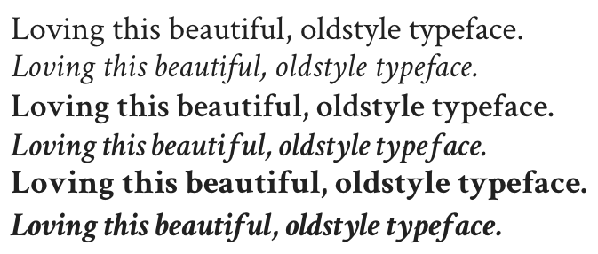

2) Harmattan
Harmattan is a typeface on Google Fonts that was actually originally intended to suit Arabic scripts, but it also looks great on Latin characters -- and would love attractive in either headline or body copy.
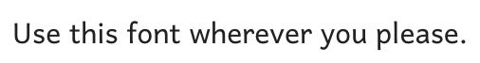

3) Torcao
Torcao is a unique combination of letters that are "half square, half circle," robust and technical while at the same time, light-hearted and inviting. It a great headline typeface, but it still quite legible in longer text. The family comes in nine weights (slender to black) and has both condensed and extender selections for a complete set of forty-eight fonts.
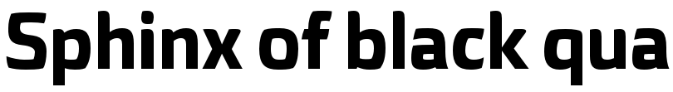

4) King Basil
This free brush font posted on Behance is great for commercial materials like social media images and flyers. It's a Lite version of the designer's "Full King Basil," and it contains many swashes and connecting letters that make for a beautiful, script-like font.
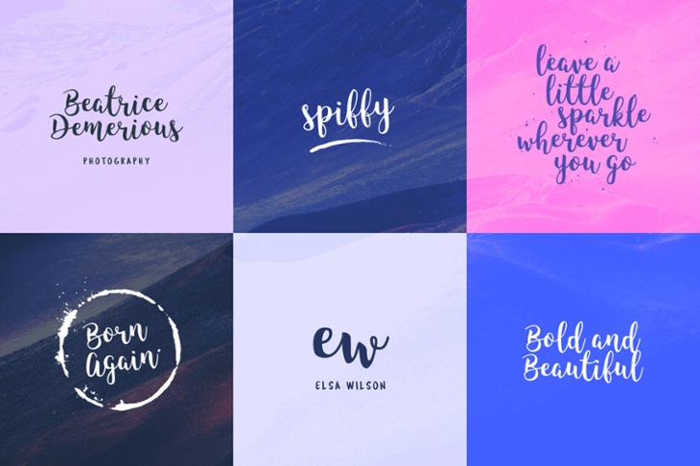

5) Merriweather
Merriweather was designed to be a typeface that's pleasant and easy to read on screens, making it perfect for a web asset like your homepage or blog. It's an evolving project on Google Fonts and will be updated, but right now, you'll find four styles -- Regular, Light, Bold, and Black -- along with the italic styles of those weights
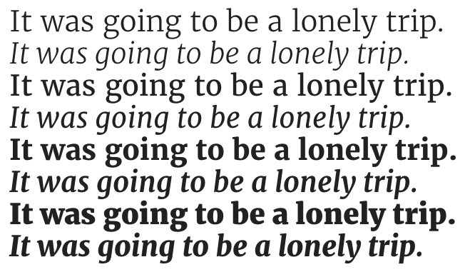

6) Poiret One
Poiret One is a long-time favorite of mine. It's described on Google Fonts as "a fresh, decorative, geometric grotesque with a hint of Art Deco and constructivism." It's sleek, simple, decorative, and great for short texts. Try it on large signs, labels, posters, T-shirts, titles, or headlines.
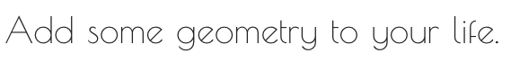

7) True North
A vintage-inspired headline typeface from HypeForType with sixteen different styles and a monoline script. It also includes free labels and extras like wild animals, numbers, symbols, tools, and other icons. True North comes with labels, extras and free banners. Extras include wild animals, catchwords, numbers, symbols, tools, maple leaves and trees. True North is a headline font with alternate capitals.
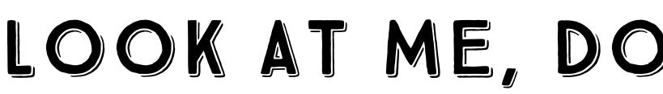

8) Bravery
Here's a cool free font posted on Behance created by a professional font creator who was kind enough to accompany the free download with the mockups below. These mockups show folks how they can play around with the font in their own designs. It comes in capital letters and numbers only, and is great for headlines or social media images like the ones below.
