STEP 1 TRIALS ON SCREEN
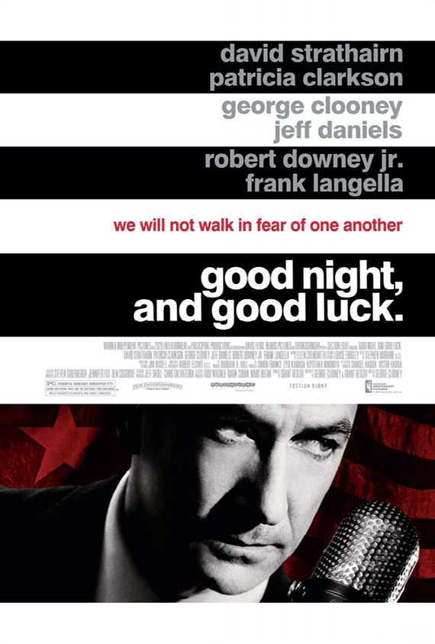
Good Night and Good Luck, by George Clooney, 2005.
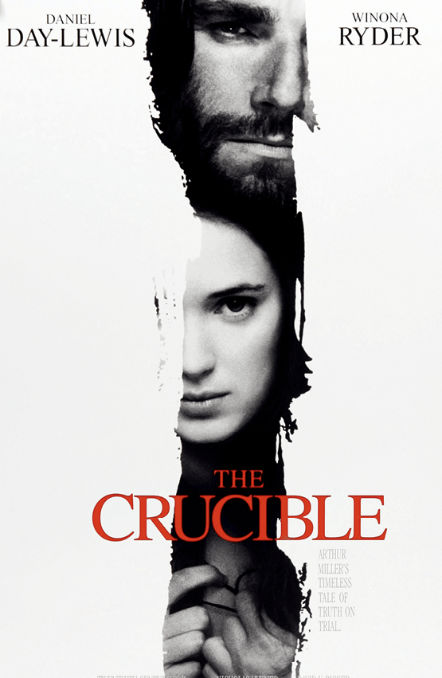
The Crucible, by Nicholas Hytner, 1996.

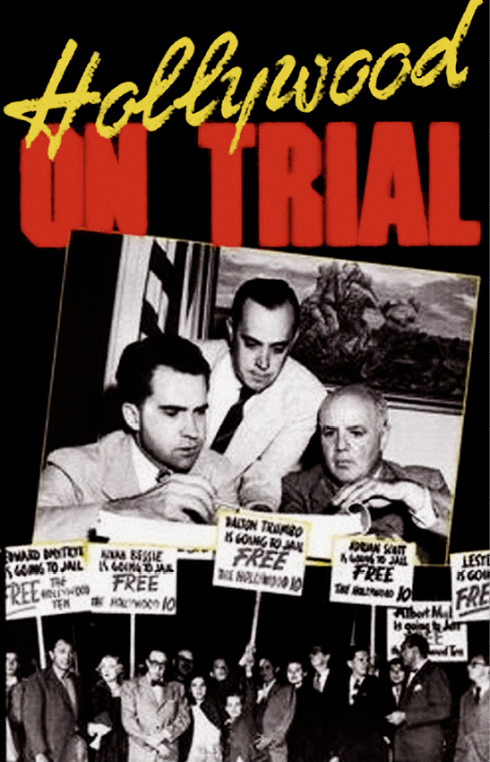
Hollywood on Trial, by David Helpern, 1976.
Choose one document and do the following tasks:
- Look at the poster and imagine what the movie is about.
- Look for information about your film online. Pick out key elements: names of the main characters, historical context…. Be ready to present it !
- What kind of witch hunt is depicted in your film?

Share your findings with your classmates
- What are the differences and similarities between these films?
- Which films would you most and least like to watch? Justify your choices

